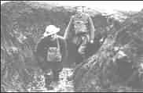

No washing or shaving here, and the demands of nature answered as quickly as possible in the handiest and deepest shell-hole. *Guy Chapman*

The stench of the dead bodies now is awful as they have been exposed to the sun for several days, many have swollen and burst. The trench is full of other occupants, things with lots of legs, also swarms of rats*. Sergeant A Vine*

The trench, when we reached it, was half full of mud and water. We set to work to try and drain it. Our efforts were hampered by the fact that the French, who had first occupied it, had buried their dead in the bottom and sides. Every stroke of the pick encountered a body. The smell was awful. *Private Pollard*

The other one said to me "Chas, I am going home to my wife and kids. I'll be some use to them as a cripple, but none at all dead! I am starving here, and so are they at home, we may as well starve together." With that he fired a shot through his boot. When the medics got his boot off, two of his toes and a lot of his foot had gone. But the injuring oneself to get out of it was quite common. *Charles Young*

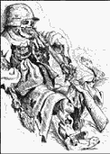

If you have never had trench feet described to you. I will tell you. Your feet swell to two or three times their normal size and go completely dead. You could stick a bayonet into them and not feel a thing. If you are fortunate enough not to lose your feet and the swelling begins to go down. It is then that the intolerable, indescribable agony begins. I have heard men cry and even scream with the pain and many had to have their feet and legs amputated. *Sergeant Harry Roberts*

All we lived on was tea and dog biscuits. If we got meat once a week we were lucky, but imagine trying to eat standing in a trench full of water with the smell of dead bodies nearby. *Richard Beasley*

The other soldiers in the hut took their shirts off after tea. They were catching lice. We had never seen a louse before, but they were here in droves. The men were killing them between their nails. *Henry Gregory*

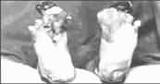

# Activity

Imagine that you are a soldier living in the trenches. Write a letter home describing the conditions in the trenches.

These feet have trench foot and frostbite caused by standing for hours in a freezing waterlogged trench. To avoid this condition soldiers were told to change their socks regularly, wear waterproof footwear or gumboots and cover their feet with whale oil.

© 2002 [www.historyonthenet.com](http://www.historyonthenet.com)