Trench Foot
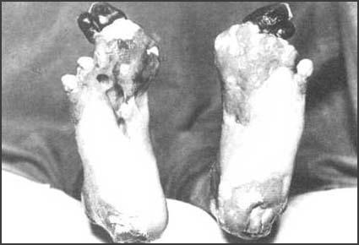
Many soldiers fighting in the First World War suffered from trench foot. This was an infection of the feet caused by cold, wet and insanitary conditions. In the trenches men stood for hours on end in waterlogged trenches without being able to remove wet socks or boots. The feet would gradually go numb and the skin would turn red or blue. If untreated, trench foot could turn gangrenous and result in amputation. Trench foot was a particular problem in the early stages of the war. For example, during the winter of 1914-15 over 20,000 men in the British Army were treated for trench foot.
The only remedy for trench foot was for the soldiers to dry their feet and change their socks several times a day. By the end of 1915 British soldiers in the trenches had to have three pairs of socks with them and were under orders to change their socks at least twice a day.
As well as drying their feet, soldiers were told to cover their feet with a grease made from whale-oil. It has been estimated that a battalion at the front would use ten gallons of whale-oil every day.
This is a picture of the waterlogged trenches they had to stand in:
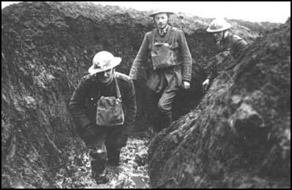
1) After the war, Captain G. H. Impey, 7th Battalion,
Royal Sussex Regiment, wrote about his experiences of
trench life.
The trenches were wet and cold and at this time some of
them did not have duckboards and dug-outs. The battalion
lived in mud and water. Altogether about 200 men were
evacuated for trench feet and rheumatism. Gum boots were
provided for the troops in the most exposed positions. Trench
feet was still a new ailment and the provision of dry socks
was vitally important. Part of the trench was reserved for
men to go two at a time, at least once a day, and rub each
other's feet with grease.

Activities
1. What caused Trench Foot?
2. Describe how you would know if you had Trench Foot.
3. What steps did the army take to make sure soldiers didn’t catch Trench Foot?

