The Horrors of Trench Mouth
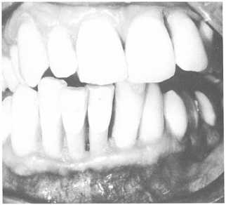

Trench mouth is a bacterial infection of the gums that produces bleeding gums, crater-like ulcers between the gums and teeth and the gradual decomposition of its victim’s jaw.
When not treated properly trench mouth can spread to the cheeks, lips or jawbone. In these circumstances trench mouth can seriously damage bone and gum tissue. Trench mouth can also enter the blood stream and spread to other parts of the body. Trench mouth makes eating and swallowing food so painful that it frequently results in involuntary weight loss. Fever and swelling of the lymph nodes is associated with trench mouth as well. People with compromised immune systems are at risk of developing very severe trench mouth infections.
The exact causes of trench mouth remain unclear, but smoking, stress and poor oral hygiene all increase the dangers of contracting trench mouth.
Trench mouth’s name comes from its prevalence amongst the soldiers in the trenches of World War I. The extreme conditions in the trenches all contributed to an epidemic of the disease during the war.

Activities
1. What increased the danger of contracting Trench Mouth?
2. Describe how you would know if you had Trench Mouth.

