Come on Aussie, come on!
Assess the PRIMARY SOURCES below and answer the questions.
Image of a Australian World War One recruiting poster, courtesy of the Australian War Memorial.
(Copyright the A.W.M.)
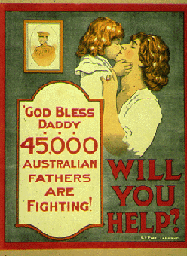
- What emotions does the poster appeal to?
……………………………………………………………………………………………………………………………………………………………………………………………………………………………………………………………………………………………….…………………………………………………………………………………………………………………………………………………………………………………………………………………………………………………………………………………………………………………………………………………….
- Who does it appeal to in the Australian community?
……………………………………………………………………………………………………………………………………………………………………………………………………………………………………………………………………………………………….………………………………………………………………………………………………………………………………………………………………………………………
- How useful would this poster be in explaining methods used by the Australian Government to encourage volunteers?
……………………………………………………………………………………………………………………………………………………………………………………………………………………………………………………………………………………………….………………………………………………………………………………………………………………………………………………………………………………………

Image of a Australian World War One recruiting poster, courtesy of the Australian War Memorial.
(Copyright the A.W.M.)
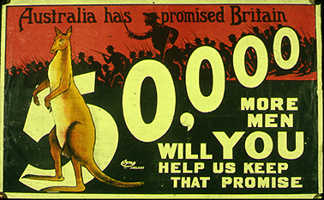

- What emotions does the poster appeal to?
……………………………………………………………………………………………………………………………………………………………………………………………………………………………………………………………………………………………….…………………………………………………………………………………………………………………………………………………………………………………………………………………………………………………………………………………………………………………………………………………….
- Who does it appeal to in the Australian community?
……………………………………………………………………………………………………………………………………………………………………………………………………………………………………………………………………………………………….………………………………………………………………………………………………………………………………………………………………………………………
- How useful would this poster be in explaining methods used by the Australian Government to encourage volunteers?
……………………………………………………………………………………………………………………………………………………………………………………………………………………………………………………………………………………………….…………………………
- Does it appeal to our national pride that, we as Australians, should keep our promise to Britain? Explain your answer with reference to the Anzac ideals.
……………………………………………………………………………………………………………………………………………………………………………………………………………………………………………………………………………………………….…………………………

Courtesy of the Australian War Memorial.
(Copyright the A.W.M.)
https://www.awm.gov.au/education/diaryofananzac/Activity%20five_Diarydetectives.pdf

Herbert wrote about his first day in action on 25 April 1915. Read the following and see what you can discovery about the landscape on Gallipoli.
“On reaching the beach we got rid of our equipment and with our section officer Captain Wassail climbed the first ridge. Here we found this pretty unhealthy for our first duty in action came very soon for as we reached the crest of the ridge we came upon a chap badly wounded, he was attended to and my 3 mates (we work in parties of 4) set out to carry him to the beach. This proved to be a difficult undertaking down the steep side of the hill, there are no tracks to follow and the wounded have to be carried down sideways on or they would slide off the stretcher. Then the scrub which is about 5 ft high and pretty thick, also the loose rocks which roll down into the gully when dislodged give no end of trouble, however the wounded seem prepared to put up with the rough handling they receive in being brought in and which we are unable to prevent under the circumstances.”

Now that you have read the diary entry draw below what you think Gallipoli looked like.

