The Role of Nurses during World War 1

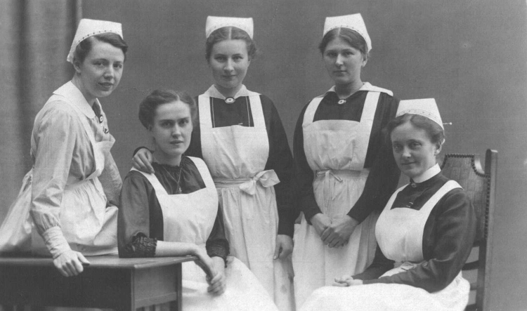
The first sisters to form the medical units left Australia in September 1914. They followed the Australian troops to all parts of the world, including Egypt, England, France, Belgium and Mesopotamia (now occupied in part by modern-day Iraq). They served in hospitals, hospital ships and hospitals constructed under tents without any floor covering.
The duties of the army nurses were much more varied than would have been the case in the civilian nursing profession. They were often forced to improvise, using what limited and under-resourced supplies and equipment they had. They needed to be decisive and quick-thinking when determining treatment, cleaning wounds and attending to minor surgery. Physical strength and a high level of efficiency were required. They endured an excessive workload and a lack of staff to meet the demands. It has been calculated that during World War I, one matron, 15 sisters and 30 staff nurses attended to 1000 patients in a makeshift hospital of hundreds of tents.
The conditions made life even more difficult for the nurses. The burden of understaffing resulted in exhaustion and they experienced shock and terror on the occasions when they came under fire. They were also at risk of contracting contagious diseases such as influenza from the sick soldiers. The nurses also experienced many of the same hardships as the soldiers. The harsh, foreign climate, inadequate basic necessities and consequent dysentery were all endured by the female nurses as well. Having seen all the horrors and devastation, many women also suffered from the same types of psychological traumas, such as depression and nightmares, which plagued the men when they returned home.
In Gallipoli, the nurses worked aboard hospital ships and had to spend a large portion of their time at sea. They travelled between the waters just outside Anzac Cove and the general hospitals on the Greek Islands, sometimes sailing up to 1050 kilometres to Alexandria in Egypt. On board these ships it was not uncommon for a nurse on night duty to look after 250 patients with only one orderly to assist her.
Perhaps one of the most difficult duties for all of the nurses was the need to remain high-spirited in the face of such adversity. Aside from being nurses, they were also women and had to be almost mother figures to their patients who were in need of comfort. Many friendships were formed between the nurses and the soldiers. This attachment would have made the loss of a soldier even more emotionally taxing for them. The Allied soldiers often commented that the Australian nurses were among the most kind and caring of the nurses.

Statistics
Throughout World War I, a total of 2139 nurses served overseas in places like Gallipoli and France, while a total of 423 served in hospitals in Australia. Of these, 25 died and 388 were honoured for their service, seven of them being awarded Military Medals. The number of lives that the Australian nurses saved can never be calculated. What we do know is that their contribution to the war earned them a new respect from not only the medical profession but also the Australian public.

Activities
- What duties did the nurses have?
- How many nurses served overseas? How many served in hospitals in Australia?
- What do you think the psychological burden placed upon the nurses would have been like? What would have contributed to this?

