Introduction to Trigonometry
Trigonometry (from Greek trigonon "triangle" + metron "measure")

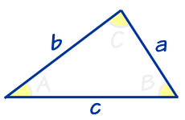 | Trigonometry ... is all about triangles.

Right Angled Triangle
A right-angled triangle (the right angle is shown by the little box in the corner) has names for each side:  - Adjacent is adjacent to the angle "θ",  - Opposite is opposite the angle, and  - the longest side is the Hypotenuse. | 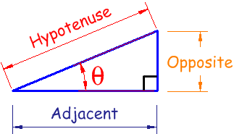

Angles
Angles (such as the angle "θ" above) can be in Degrees or Radians. Here are some examples:
Angle | Degrees | Radians
Right Angle | 90° | π/2
__ Straight Angle | 180° | π
Full Rotation | 360° | 2π

"Sine, Cosine and Tangent"
The three most common functions in trigonometry are Sine, Cosine and Tangent. You will use them a lot!
They are simply one side of a triangle divided by another.
For any angle "θ":
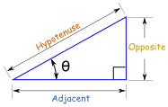 | Sine Function: sin(θ) = Opposite / Hypotenuse  Cosine Function: cos(θ) = Adjacent / Hypotenuse  Tangent Function: tan(θ) = Opposite / Adjacent

Example: What is the sine of 35°?
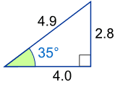 | Using this triangle (lengths are only to one decimal place):  sin(35°) = Opposite / Hypotenuse = 2.8/4.9 = 0.57...
Sine, Cosine and Tangent are often abbreivated to sin, cos and tan.

Solving Triangles
A big part of Trigonometry is Solving Triangles. By "solving" I mean finding missing sides and angles.

Example: Find the Missing Angle "C"
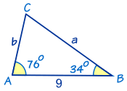

It's easy to find angle C by using angles of a triangle add to 180°:
So C = 180° - 76° - 34° = 70°

It is also possible to find missing side lengths and more. The general rule is:
If you know any 3 of the sides or angles you can find the other 3
(except for the three angles case)

Pythagoras Theorem
For the next trigonometric identities we start with Pythagoras' Theorem:
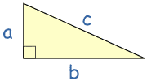 | The Pythagorean Theorem states that, in a right triangle, the square of a (a²) plus the square of b (b²) is equal to the square of c (c²):  a² + b² = c²
Dividing through by c² gives
a² | + | b² | = | c²
c² |  | c² |  | c²
This can be simplified to:
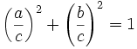
Now, a/c is Opposite / Hypotenuse, which is sin(θ)
And b/c is Adjacent / Hypotenuse, which is cos(θ)
So (a/c)² + (b/c)² = 1 can also be written:
sin² θ + cos² θ = 1

Distance Between 2 Points
Here is how to calculate the distance between two points when you know their coordinates:
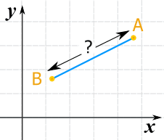 | Let us call the two points A and B
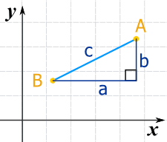 | We can run lines down from A, and along from B, to make a Right Angled Triangle.  And with a little help from Pythagoras we know that:  a² + b² = c²
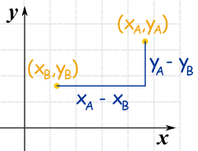 | Now label the coordinates of points A and B.  x_{A} means the x-coordinate of point A  y_{A} means the y-coordinate of point A  The horizontal distance "a" is (x_{A} - x_{B})  The vertical distance "b" is (y_{A} - y_{B})
So now we can solve for c (the distance between the points):
Start with: |  | c² = a² + b²
Put in the calculations for a and b: |  | c² = (x_{A} - x_{B})² + (y_{A} - y_{B})²
And the final result:

